**RIYA INDAP,44**

~cd

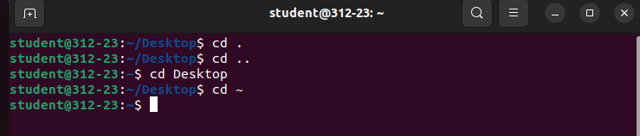

~mkdir(to make directory)



~rmdir(to remove directory)

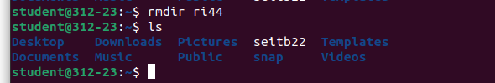

~pwd(to show the path you are in)

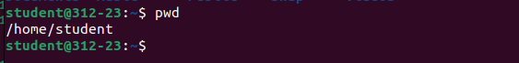

~gedit(to open and edit in a text editor)

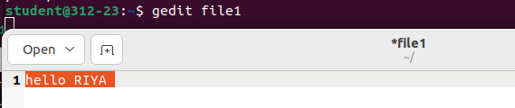

~cat(to concatenate the contents of two file)

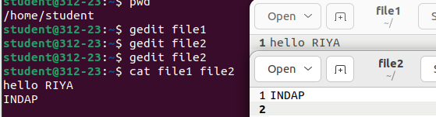

~cp(to copy content from one file to another)

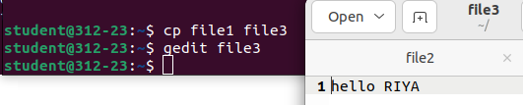

~mv(to a directory from a place)

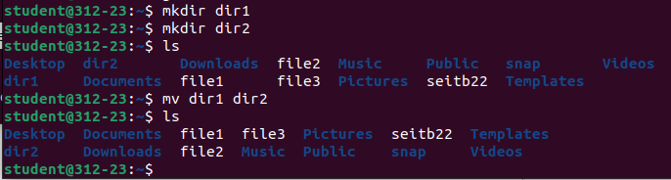

~rm(to remove a file)

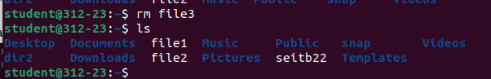

~ps(to show current status of processes)

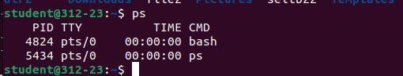

~man(gives detailed info about a command)

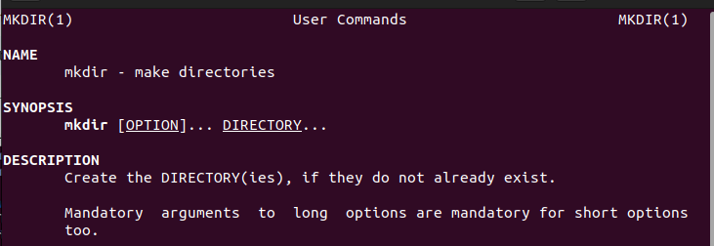

~who(gives info about the users)



~whoami(gives info about the current user)



~echo(display lines/string passed as argument)



~date(gives date,day,month and time)



~time

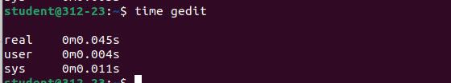

~cal(displays calendar)

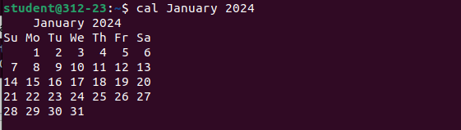

~history(gives history of commands)

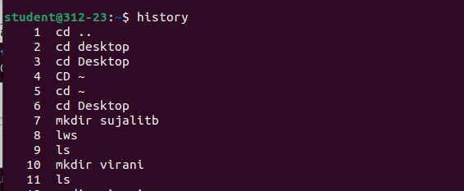

~more(shows full content of file)



~less(shows reduced content of file)



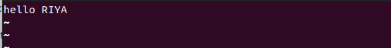

~bc(performs line calculation)

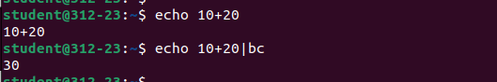

~finger(gives details of all users who have logged in)

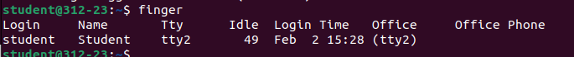

~clear(to clear the cmd)



**~POST-EXPERIMENT**

1)To display file size in human readable form



2)To order files based on Last modified time in descending order



3)To display files recursively



4)To display Weekday name in full short



5)To display current date;shown in mm//dd/yy format



6)To display time;shown as HH:MM:SS



7)To display week number of year, with Sunday as first day of week



8)To display Julian calendar and Julian days

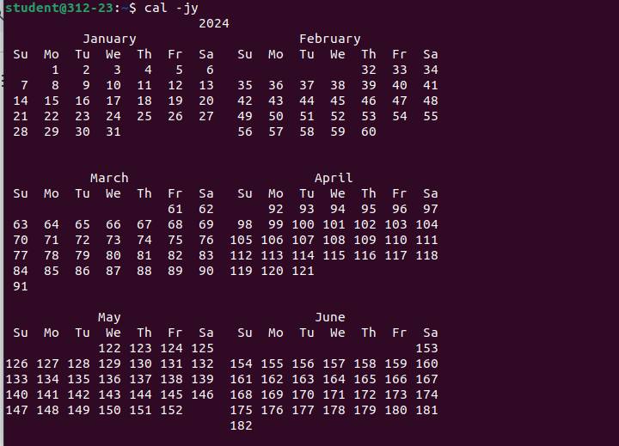

9)To add a specified number of months before or after the current one in output



10)To list Processes in a hierarchy

